|  |
| --- |
| **BATCH AND ROLL NO: Q-7 42430** |
| **EXPERIMENT NO.2** |
| **TITLE:** Design a mobile application to create home page using grid layout. |
| **DATE OF PERFORMANCE:** |
| **DATE OF SUBMISSION:** |

**Title:** Designing of mobile application to create home page using grid layout.

**Requirements:**

1 Android studio

2. Java SDK

**Theory:**

**Introduction**

In the realm of mobile application development, the design and layout of user interfaces play a pivotal role in creating a seamless and visually appealing user experience. The choice of layout managers is crucial for efficiently organizing and presenting content on the screen. One popular layout manager for achieving a structured and responsive layout is the Grid Layout.

**Grid Layout:** Grid Layout is a versatile layout manager that arranges UI components in a grid structure. This layout is particularly useful for creating home pages and dashboards in mobile applications, allowing developers to organize content in rows and columns. It provides a flexible and dynamic structure that adapts well to various screen sizes and orientations.

**Objective of the Lab:** The primary objective of this lab is to guide you through the process of designing a home page for a mobile application using the Grid Layout. You will learn how to efficiently organize and display content, such as images, text, and interactive elements, in a grid format. By the end of this lab, you should be adept at using the Grid Layout to create visually appealing and responsive home pages for your mobile applications.

**Lab Prerequisites:**

* Basic understanding of mobile application development concepts.
* Familiarity with the chosen development environment (e.g., Android Studio).
* Prior knowledge of programming languages such as Java (for Android)

### **Steps:**

### **Designing a Home Page Using Grid Layout:**

**Step 1: Set Up Your Development Environment**

* Ensure you have a suitable development environment installed, such as Android Studio for Android development.
* Create a new project or open an existing one.

**Step 2: Understand Grid Layout Basics**

* Familiarize yourself with the basic concepts of the Grid Layout, including rows, columns, and grid items.
* Explore how the Grid Layout adapts to different screen sizes and orientations.

**Step 3: Create Grid Layout in XML**

* Open the XML layout file (for Android).
* Define a Grid Layout container with a specified number of rows and columns.

**Step 4: Add UI Elements as Grid Items**

* Identify the content you want to display on the home page.
* Add UI elements (e.g., ImageView, TextView, Button) as grid items within the rows and columns of the Grid Layout.

**Step 5: Customize Grid Items**

* Customize the appearance of each grid item by adjusting properties such as size, padding, and margins.
* Consider using features like span to merge multiple rows or columns for specific elements.

**Step 6: Handle Interactions and Navigation**

* If applicable, implement interaction elements such as buttons or clickable components.
* Set up navigation or actions for grid items, allowing users to navigate to other pages or perform specific tasks.

**Step 7: Test Responsiveness**

* Test your home page layout on various devices and screen sizes to ensure responsiveness.
* Adjust layout parameters as needed to optimize the appearance on different devices.

**Step 8: Implement Dynamic Data**

* If your home page involves displaying dynamic content (e.g., images from a server, user-specific information), implement the necessary logic to fetch and populate the data within the Grid Layout.

**Step 9: Test and Debug**

* Test your home page thoroughly, including user interactions and data retrieval.
* Use debugging tools to identify and address any issues that may arise during testing.

**Step 10: Iterate and Enhance**

* Gather user feedback and iterate on the design based on usability and user experience.
* Consider enhancing the home page with animations, transitions, or additional features to make it more engaging.

**XML Code:**

**<?xml version="1.0" encoding="utf-8"?>**

**<RelativeLayout xmlns:android="http://schemas.android.com/apk/res/android"**

**xmlns:app="http://schemas.android.com/apk/res-auto"**

**xmlns:tools="http://schemas.android.com/tools"**

**android:layout_width="match_parent"**

**android:layout_height="match_parent"**

**tools:context=".MainActivity">**

**<GridLayout**

**android:layout_width="match_parent"**

**android:layout_height="match_parent"**

**android:rowCount="3"**

**android:columnCount="2">**

**<androidx.cardview.widget.CardView**

**android:layout_height="wrap_content"**

**android:layout_width="wrap_content"**

**android:layout_column="0"**

**android:layout_row="0"**

**android:layout_columnWeight="1"**

**android:layout_rowWeight="1">**

**<LinearLayout**

**android:layout_width="wrap_content"**

**android:layout_height="wrap_content"**

**android:orientation="vertical"**

**android:gravity="center"**

**android:layout_gravity="center_vertical|center_horizontal">**

**<ImageView**

**android:layout_width="wrap_content"**

**android:layout_height="wrap_content"**

**android:src="@drawable/baseline_home_24"/>**

**<TextView**

**android:layout_width="wrap_content"**

**android:layout_height="wrap_content"**

**android:text="Home"/>**

**</LinearLayout>**

**</androidx.cardview.widget.CardView>**

**<androidx.cardview.widget.CardView**

**android:layout_height="wrap_content"**

**android:layout_width="wrap_content"**

**android:layout_column="1"**

**android:layout_row="0"**

**android:layout_columnWeight="1"**

**android:layout_rowWeight="1">**

**<LinearLayout**

**android:layout_width="wrap_content"**

**android:layout_height="wrap_content"**

**android:orientation="vertical"**

**android:gravity="center"**

**android:layout_gravity="center_vertical|center_horizontal">**

**<ImageView**

**android:layout_width="wrap_content"**

**android:layout_height="wrap_content"**

**android:src="@drawable/baseline_contacts_24"/>**

**<TextView**

**android:layout_width="wrap_content"**

**android:layout_height="wrap_content"**

**android:text="Contacts"/>**

**</LinearLayout>**

**</androidx.cardview.widget.CardView>**

**<androidx.cardview.widget.CardView**

**android:layout_width="133dp"**

**android:layout_height="wrap_content"**

**android:layout_row="1"**

**android:layout_rowWeight="1"**

**android:layout_column="0"**

**android:layout_columnWeight="1"**

**android:background="@drawable/card_border">**

**<LinearLayout**

**android:layout_width="wrap_content"**

**android:layout_height="63dp"**

**android:layout_gravity="center_vertical|center_horizontal"**

**android:gravity="center"**

**android:orientation="vertical">**

**<ImageView**

**android:layout_width="wrap_content"**

**android:layout_height="wrap_content"**

**android:src="@drawable/baseline_account_balance_24" />**

**<TextView**

**android:layout_width="wrap_content"**

**android:layout_height="wrap_content"**

**android:text="Account" />**

**</LinearLayout>**

**</androidx.cardview.widget.CardView>**

**<androidx.cardview.widget.CardView**

**android:layout_height="wrap_content"**

**android:layout_width="wrap_content"**

**android:layout_column="1"**

**android:layout_row="1"**

**android:layout_columnWeight="1"**

**android:layout_rowWeight="1">**

**<LinearLayout**

**android:layout_width="wrap_content"**

**android:layout_height="wrap_content"**

**android:orientation="vertical"**

**android:gravity="center"**

**android:layout_gravity="center_vertical|center_horizontal">**

**<ImageView**

**android:layout_width="wrap_content"**

**android:layout_height="wrap_content"**

**android:src="@drawable/baseline_access_time_24"/>**

**<TextView**

**android:layout_width="wrap_content"**

**android:layout_height="wrap_content"**

**android:text="Transaction History"/>**

**</LinearLayout>**

**</androidx.cardview.widget.CardView>**

**<androidx.cardview.widget.CardView**

**android:layout_height="wrap_content"**

**android:layout_width="wrap_content"**

**android:layout_column="0"**

**android:layout_row="2"**

**android:layout_columnWeight="1"**

**android:layout_rowWeight="1">**

**<LinearLayout**

**android:layout_width="wrap_content"**

**android:layout_height="wrap_content"**

**android:orientation="vertical"**

**android:gravity="center"**

**android:layout_gravity="center_vertical|center_horizontal">**

**<ImageView**

**android:layout_width="wrap_content"**

**android:layout_height="wrap_content"**

**android:src="@drawable/baseline_add_card_24"/>**

**<TextView**

**android:layout_width="wrap_content"**

**android:layout_height="wrap_content"**

**android:text="Add Card"/>**

**</LinearLayout>**

**</androidx.cardview.widget.CardView>**

**<androidx.cardview.widget.CardView**

**android:layout_height="wrap_content"**

**android:layout_width="wrap_content"**

**android:layout_column="1"**

**android:layout_row="2"**

**android:layout_columnWeight="1"**

**android:layout_rowWeight="1">**

**<LinearLayout**

**android:layout_width="wrap_content"**

**android:layout_height="wrap_content"**

**android:orientation="vertical"**

**android:gravity="center"**

**android:layout_gravity="center_vertical|center_horizontal">**

**<ImageView**

**android:layout_width="wrap_content"**

**android:layout_height="wrap_content"**

**android:src="@drawable/baseline_account_box_24"/>**

**<TextView**

**android:layout_width="wrap_content"**

**android:layout_height="wrap_content"**

**android:text="Account"/>**

**</LinearLayout>**

**</androidx.cardview.widget.CardView>**

**</GridLayout>**

**</RelativeLayout>**

**Java Code:**

**package com.example.expt2AD_gridlayout;**

**import androidx.appcompat.app.AppCompatActivity;**

**import android.os.Bundle;**

**public class MainActivity extends AppCompatActivity {**

**@Override**

**protected void onCreate(Bundle savedInstanceState) {**

**super.onCreate(savedInstanceState);**

**setContentView(R.layout.activity_main);**

**}**

**}**

**Output:**

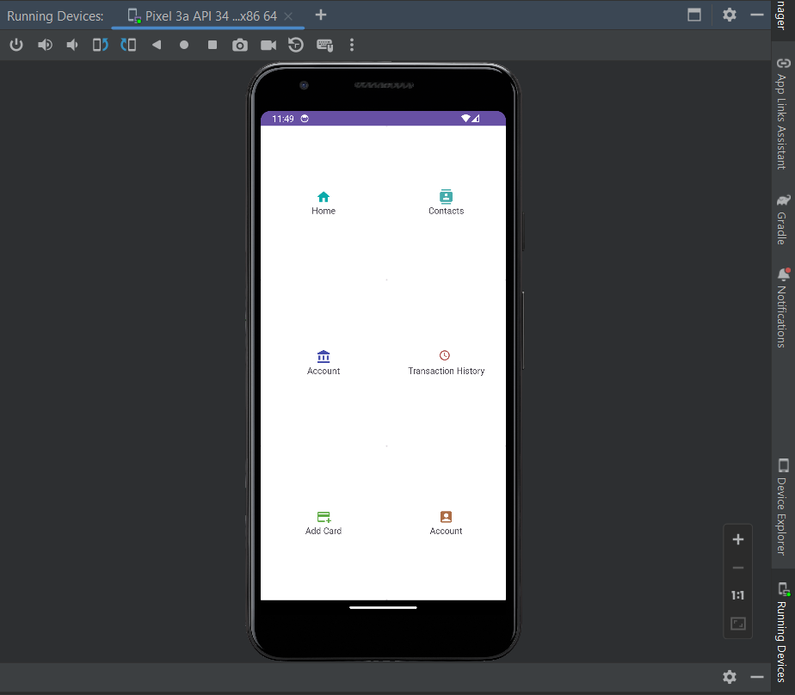

#### Conclusion:

#### ………………………………………………………………………………………………………………………………………………………………………………………………………………………………………………………………………………………